Software Quality Assurance 7A

**Point Of Sale**

|  |  |
| --- | --- |
| Muhammad Maaz Khan | CS161118 |
| Jinsaar Ali | CS161063 |
| Hafiz Muhammad Waqas | CS161063 |
| Usman Khan | CS152007 |
| Muhammad Hasan Khan | CS151086 |
| Taha Rabbani | CS142028 |

Submitted To

**Ubaid Aftab Chawla**

# Method & Quality Planning Document

# Management Responsibility

**Responsibility of the Company**

The responsibility of the company is to ensure the quality of the software that would meet the user requirements with correct output.

**Quality Achievement Steps**

We will take six Quality achievement steps and the following are as follows:

* We will define the quality characteristics of the product
* We will measure each quality characteristics
* We will set the quality standard for each quality characteristics
* We will control quality against those standards
* We will find and correct causes of poor quality
* We will make continuous to make improvements

**Quality Policy**

We will provide service that would meet the expectation of our customers.

# Responsibility & Authority

**Responsibility of the Client**

* Client should have a complete business knowledge to have efficient communication with the project manager
* Client should cooperate with the project manager to maintain or increase the quality of a software

**Responsibility of the Team Members**

* Team members should take appropriate actions to ensure the quality of the software
* Team members should make proper test cases for each deliverables
* Team members should fulfill all the quality achievements steps as described above

# Quality System

We will ensure the quality of the system by making correct test cases and use case and checking all the deliverables that whether they are in best in quality or not. This system will get reviewed by the concerned authority and we will update and improve the system accordingly to their feedback.

**Steps taken for CMMI level 2**

We have taken the following steps for the CMMI level 2 and the following are as follows:

* Requirement Elicitation
* Software Project Plan
* Software Project Tracking & Monitoring
* Integrated Software Management
* Software Quality Assurance
* Intergroup Coordination
* Peer Review

**Quality Planning & Standards**

We will check the quality of a software in five different views of quality and we will use CMMI level 3 as a base standard and the following quality planning are as follows:

* Validation
* Verification
* Integration Testing
* Unit Testing

**Quality Milestones**

|  |  |  |
| --- | --- | --- |
| **Milestones** | **Description** | **Due Date** |
| Main Screen | Container to hold activities and side bar having POS , Sale Report and Exit buttons | 15/04/19 |
| POS | Menu Table, Items Selection, Setting Discount, Amount Received, Print Bill | 16/04/19 |
| Sale Report | Overall Report | 17/04/19 |
| POS(Update) | Order Type, Setting Discount On individual Item, Cash Return | 20/04/19 |
| Sale Report | Report Category on monthly basis, daily and yearly, duration basis | 21/04/19 |
| POS (update) | Print Token, delete items, selection on category | 22/04/19 |
| Exit | Close the project | 25/04/19 |

# **Document Control**

**Document Standards**

We will use ISO 9001:2015 as our document standards and some the protocol are as follows:

* Approve documents for prior of issue
* Review, update as necessary and re-approve the documents
* Identify the changes and current document revision standards
* Make non relevant documents available at point of use
* Prevent obsolete documents from unintended use

For that project we will use SRS & SDS to define goals and designs and the following pictures will describe the template of SRS & SDS.

**SRS:**

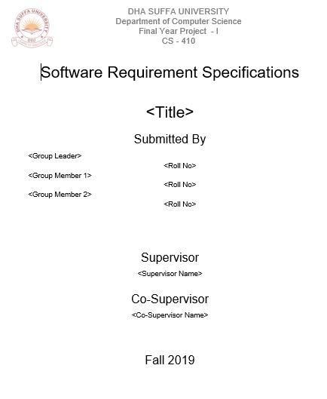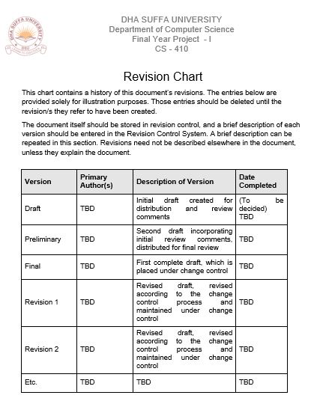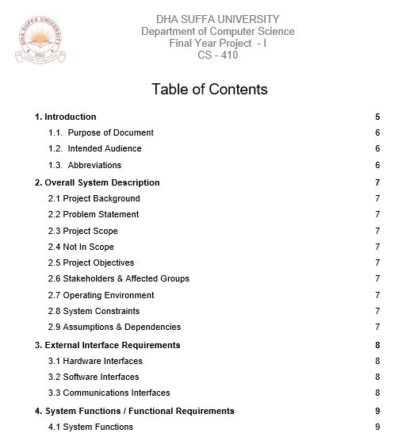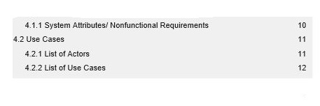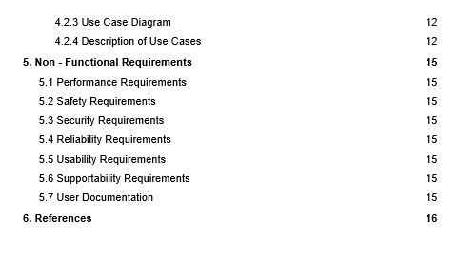

**SDS:**

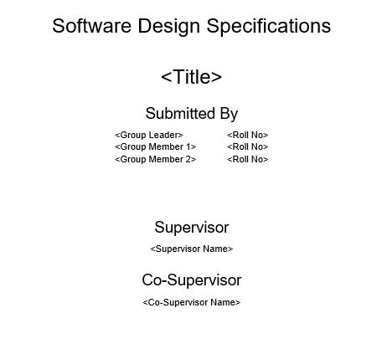

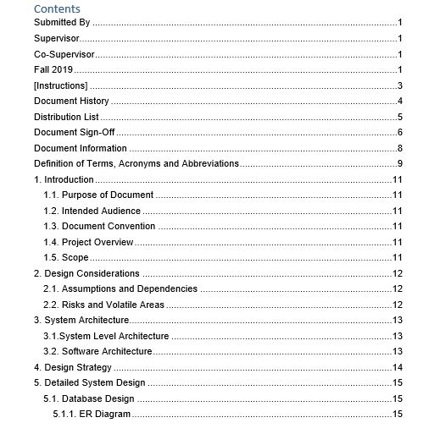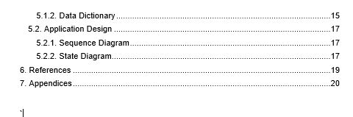

**Identification of Each Document**

This document will consist of all the testing’s and methodologies that used in this project.

**Approved procedures**

All the procedures will be approved by the supervisor of this course and supervisor will ensures the proper procedures and documentation.

**Document changes**

There is no document changed or data changed in the file and the following table will describe the document version.

|  |  |  |
| --- | --- | --- |
| **Document** | **Version** | **Date** |
| Testing | 1.0 | 18/04/19 |
| Testing | 2.0 | 22/04/19 |
| Testing | 2.1 | 25/04/19 |

**Data Control Document**

The following table will describe the data control procedure for this file.

|  |  |  |
| --- | --- | --- |
| **Document** | **Reviewed** | **Date** |
| Testing | Y | 25/12/19 |

# Process Identification & Traceability Procedures

**Process Control**

The **Process Model** methodology that is used in this project is **waterfall**. The following phases of waterfall are as follows:

* Requirement Definition
* Analysis
* Design
* Implementation
* Testing
* Maintenance

**ER Diagram:**

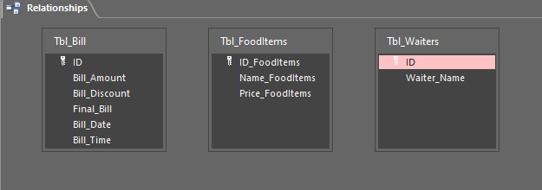

# Inspection & Testing

**Plans for Testing**

The following plans of testing are as follows:

* We will use different test techniques to ensure the quality of the software
* Our supervisor will ensure all the techniques that was used in testing
* There will be regular meetings to ensure that whether the procedures are correctly executed or not.

The following template for the meetings sheets are shown below:

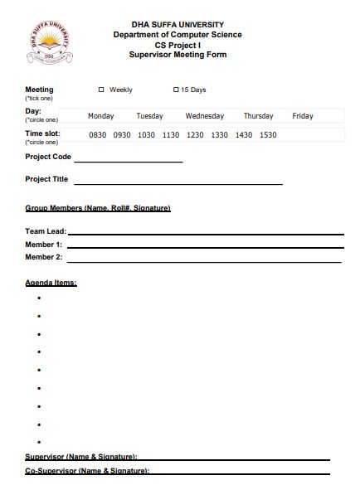

# Training need

* The seminar will be held to ensure that an employee will do the right task at first time.
* The training would encourages employees and this training would help us to reduce the cost of failure.

# Handling, Storage, Packaging & Delivery

This software will distribute online it does not required any packaging and delivery logistics however this software will be stored in Google Store so that user can download this project.

# Testing Strategy & Acceptance Test Specification Documents

**Introduction**

**Document Purpose & Overview**

The purpose of this document is to conduct testing and validate/ verify all the deliverables and this would ensure that the system has a good quality.

**Project Overview**

This project will reserve a seat of your favorite restaurant with your desire time and you can cancel your reservation and restaurant owners can add their place in the system and the customers can book a seats.

**Objectives of Testing**

The following objective of testing are as follows:

* To confine the standards of CMMI level 3
* To ensure the quality of the software
* To learn and familiarize our self to the testing phase
* Perform quality assurance

**Scope & Techniques of Testing**

The scope of the this project is the reserve the seats in the desire hotels and the following testing techniques are as follows

* Unit testing
* Integration testing
* System testing
* Black box testing
* White Box testing
* User Acceptance testing
* Beta testing
* Regression Testing

# **Test Procedure**

**Testing steps**

We will follow the following Testing steps

* Requirement analysis
* Design process
* Development
* Testing process and debugging
* Maintenance

**Starting & Ending Criteria**

The following Stating Criteria are as follows:

* Test Plan
* Testable code with working database

The following Ending Criteria are as follows:

* Test Logs
* Complete executions of test cases

**Responsibility of People**

|  |  |
| --- | --- |
| Name | Responsibility |
| Muhammad Maaz Khan | Development, Testing |
| Jinsaar Ali | Testing ,Documentation |
| Hafiz Muhammad Waqas | Testing |
| Usman Khan | Testing |
| Muhammad Hasan Khan | Testing |
| Taha Rabbani | Testing |

**Testing Environment**

Windows operating system will be the major testing environment for this project.

# Validation Test Report

|  |  |  |
| --- | --- | --- |
| No | Product Requirement | Pass/Fail |
|  | **General** |  |
| RQ1 | Chap Shoro shall have POS and Sale Report | Pass |
| RQ2 | POS shall have tables count, items to select and generate bill | Pass |
| RQ3 | Sale Report shall generate daily reports | Pass |
| RQ4 | POS shall have order types | Pass |
| RQ5 | POS shall have option to offer discounts | Pass |
| RQ6 | POS on Delivery mode shall have information of customer | Pass |
| RQ7 | Bill shall have essential information | Pass |
| RQ8 | Sale Report should generate on durations | Pass |
| RQ9 | POS can edit quantity, delete items, update items | Pass |
|  | **Database** |  |
| RQ10 | The database shall contain a table | Pass |
| RQ11 | The database shall have several fields such as items, sales and waiters. | Pass |

**Acceptance Criteria**

The following user story that fulfill the acceptance criteria are as follows:

* The user will open this application for the first time & and he will sign up and then he will login and then he will select his favorite restaurant and then he will reserve his desire seats and time and he can reserve seats in different restaurant and if he wish he can also cancel the reservation of that particular restaurant
* The user will open this application for the second or several time & and he will sign up and then he will login and then he will select his favorite restaurant and then he will reserve his desire seats and time and he can reserve seats in different restaurant and if he wish he can also cancel the reservation of that particular restaurant
* The user will open this application for the second or several time & and he will sign up and then he will login and then he will select his favorite restaurant and then he will reserve his desire seats and time and close that app
* The restaurant owner can sign up his restaurants with limited seats with location and restaurant names and the user can reserve a seats

**Form Testing, Query Testing & Integrity Testing**

All the form testing has been conducted with the test cases given below and 99% of the test cases were passed. Query Testing & Integrity Testing has been done during the test cases below and also we verified the tables of the database and the pictures are show below:



# Test Cases

|  |  |
| --- | --- |
| **Test case** | **POS screen_001** |
| **Test date** | **1/1/20** |
| **Status** | **Tested** |
| **Review Date** | **2/1/20** |
| **Result** | **Pass** |

The user will put all the correct attributes.

|  |  |
| --- | --- |
| **Test case** | **POS screen_002** |
| **Test date** | **1/1/20** |
| **Status** | **Tested** |
| **Review Date** | **2/1/20** |
| **Result** | **Pass** |

The user will only enter quantity.

|  |  |
| --- | --- |
| **Test case** | **POS screen_003** |
| **Test date** | **1/1/20** |
| **Status** | **Tested** |
| **Review Date** | **2/1/20** |
| **Result** | **Pass** |

Error will generate on empty fields.

|  |  |
| --- | --- |
| **Test case** | **POS screen_004** |
| **Test date** | **1/1/20** |
| **Status** | **Tested** |
| **Review Date** | **2/1/20** |
| **Result** | **Pass** |

The user can delete and update items as

well

|  |  |
| --- | --- |
| **Test case** | **POS screen_005** |
| **Test date** | **1/1/20** |
| **Status** | **Tested** |
| **Review Date** | **2/1/20** |
| **Result** | **Pass** |

The user can enter discounts and cash

|  |  |
| --- | --- |
| **Test case** | **POS screen_006** |
| **Test date** | **1/1/20** |
| **Status** | **Tested** |
| **Review Date** | **2/1/20** |
| **Result** | **Pass** |

The user will search category wise and

through key words

|  |  |
| --- | --- |
| **Test case** | **POS screen_007** |
| **Test date** | **1/1/20** |
| **Status** | **Tested** |
| **Review Date** | **2/1/20** |
| **Result** | **Pass** |

The user cannot close screen after

generating bill until it payed

|  |  |
| --- | --- |
| **Test case** | **Sale screen_001** |
| **Test date** | **1/1/20** |
| **Status** | **Tested** |
| **Review Date** | **2/1/20** |
| **Result** | **Pass** |

The user can see sale reports

|  |  |
| --- | --- |
| **Test case** | **Sale screen_002** |
| **Test date** | **1/1/20** |
| **Status** | **Tested** |
| **Review Date** | **2/1/20** |
| **Result** | **Pass** |

Errors if month or year is not selected

|  |  |
| --- | --- |
| **Test case** | **Sale screen_003** |
| **Test date** | **1/1/20** |
| **Status** | **Tested** |
| **Review Date** | **2/1/20** |
| **Result** | **Pass** |

Users can see reports on duration basis as

well

|  |  |
| --- | --- |
| **Test case** | **Sale screen_004** |
| **Test date** | **1/1/20** |
| **Status** | **Tested** |
| **Review Date** | **2/1/20** |
| **Result** | **Pass** |

User cannot select To Date earlier than

From Date

|  |  |
| --- | --- |
| **Test case** | **POS screen_008** |
| **Test date** | **1/1/20** |
| **Status** | **Tested** |
| **Review Date** | **2/1/20** |
| **Result** | **Pass** |

User generating bill

|  |  |
| --- | --- |
| **Test case** | **POS screen_009** |
| **Test date** | **1/1/20** |
| **Status** | **Tested** |
| **Review Date** | **2/1/20** |
| **Result** | **Pass** |

User generate token

|  |  |
| --- | --- |
| **Test case** | **POS screen_010** |
| **Test date** | **1/1/20** |
| **Status** | **Tested** |
| **Review Date** | **2/1/20** |
| **Result** | **Pass** |

The user can set discount

|  |  |  |  |  |  |
| --- | --- | --- | --- | --- | --- |
| ***Steps*** | ***Validation Activity*** | ***Expected result*** | ***Test 1*** | ***Test 2*** | ***Test 3*** |
| 1. | User can set quantity only | * Item’s prices and name are not editable |  |  |  |
| 2. | User can set discount and enter amount payed | * Amount of item is set accordingly |  |  |  |
| 3. | User can set quantity only | * Item’s prices and name are not editable |  |  |  |
| 4. | User can search through keywords and category | * Item table refreshes accordingly |  |  |  |
| 5. | User can select order type | * Options hide and show accordingly |  |  |  |

|  |  |  |  |  |  |
| --- | --- | --- | --- | --- | --- |
| ***Steps*** | ***Verification/Activity*** | ***Expected result*** | ***Test 1*** | ***Test 2*** | ***Test 3*** |
| 1. | User can verify sale amount with amount on drawer | * Drawer amount should be more than daily sale amount |  |  |  |

# **Post Condition:**

POS/Sale report screen opens when the Chap Shoro application is activated

**Issues:**

None.

**ScreenShots:**

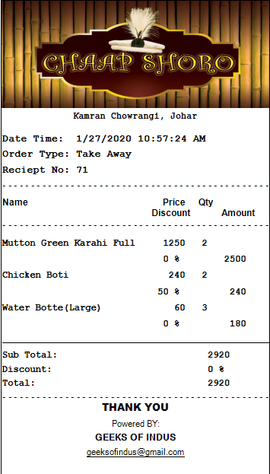

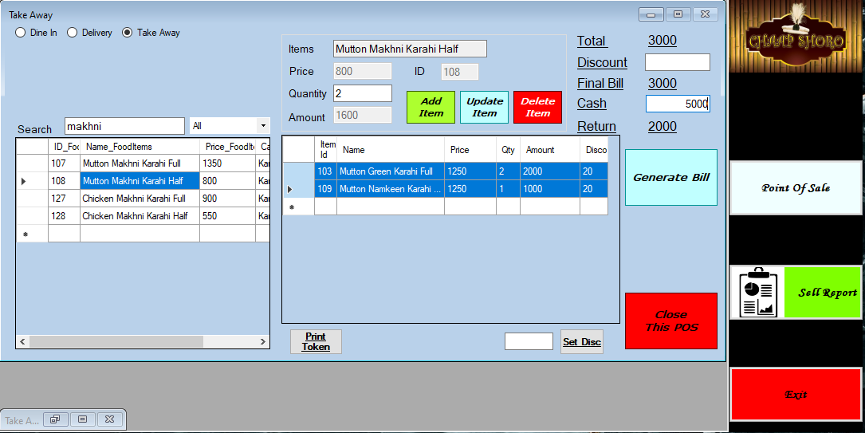

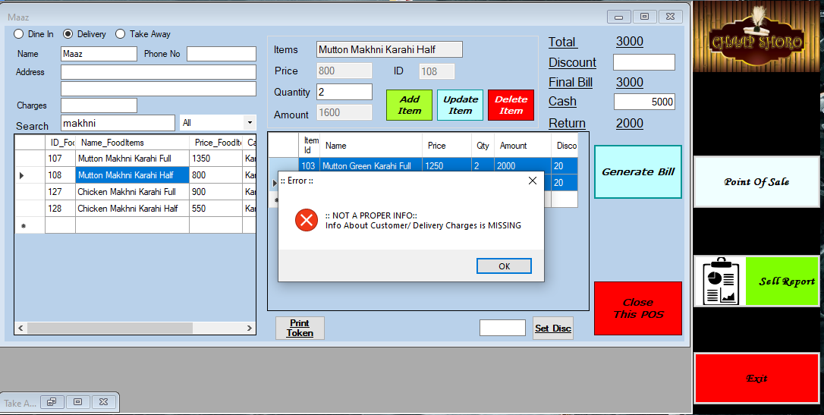

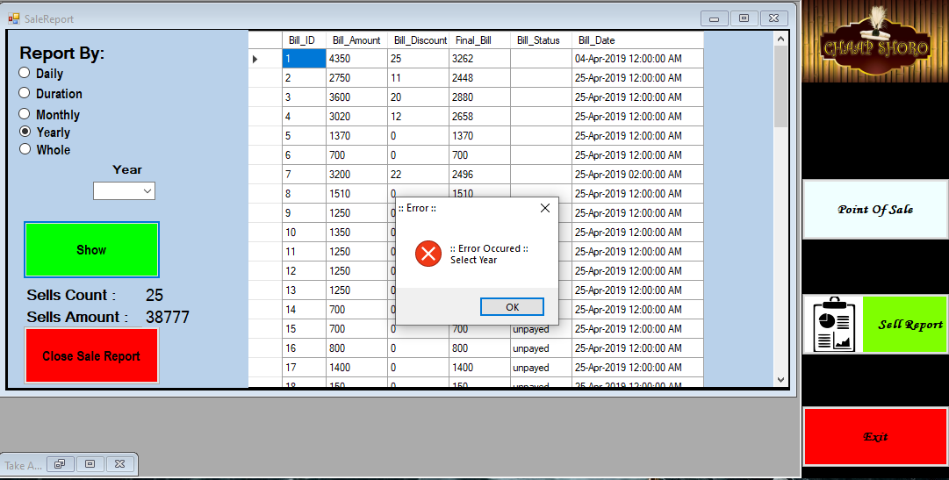

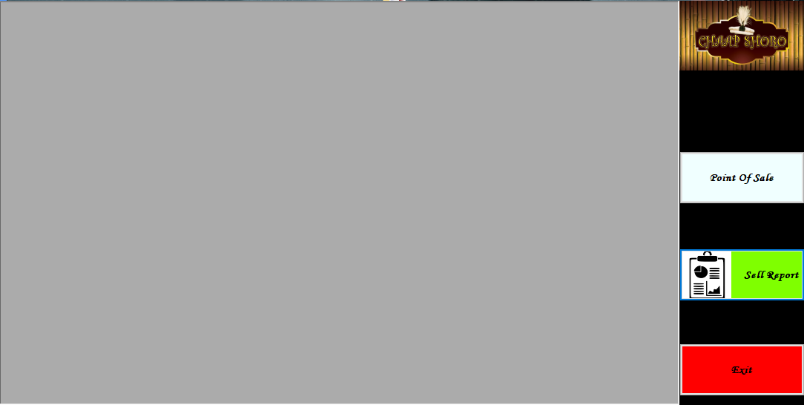

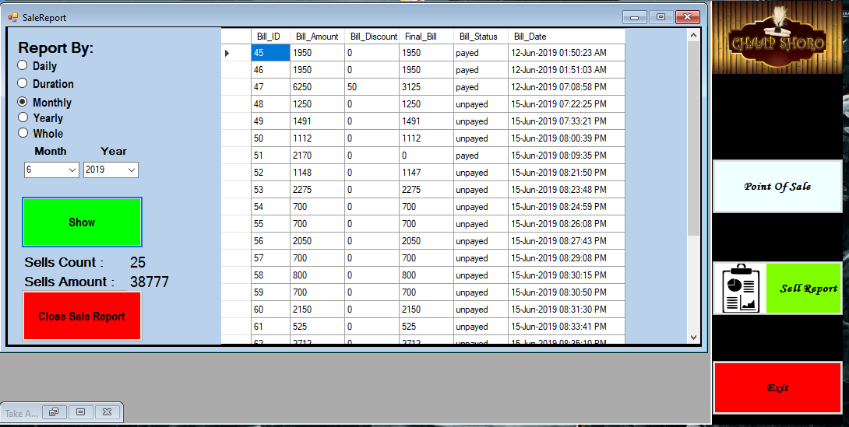

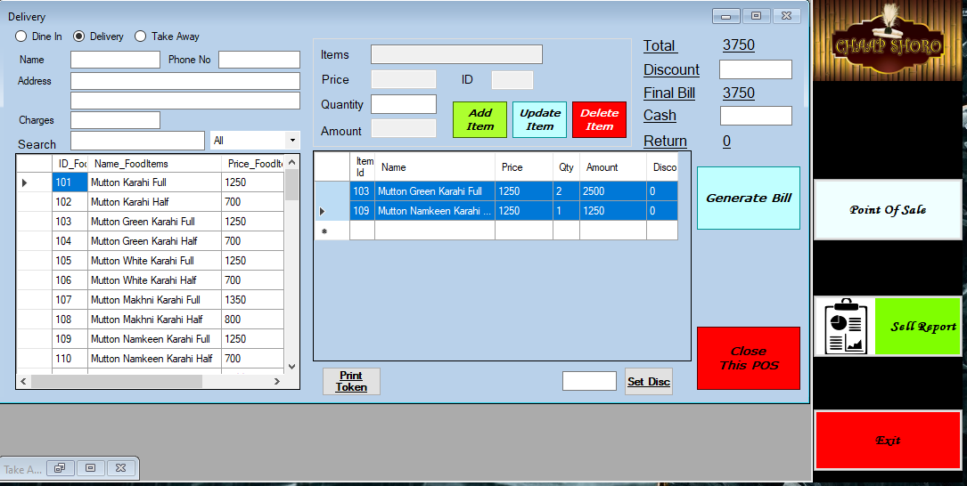

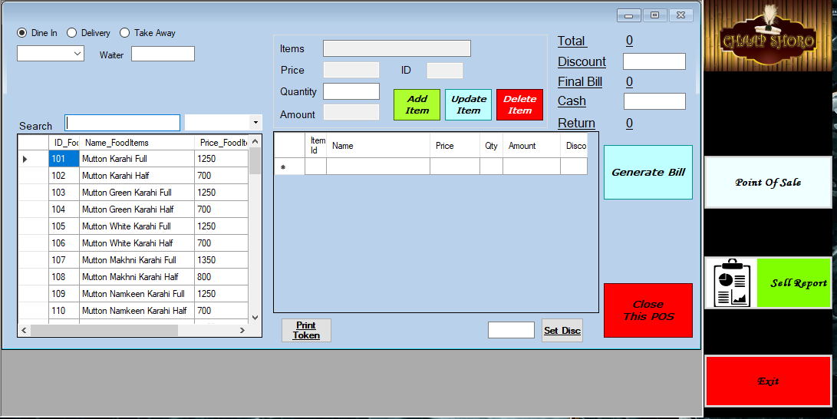

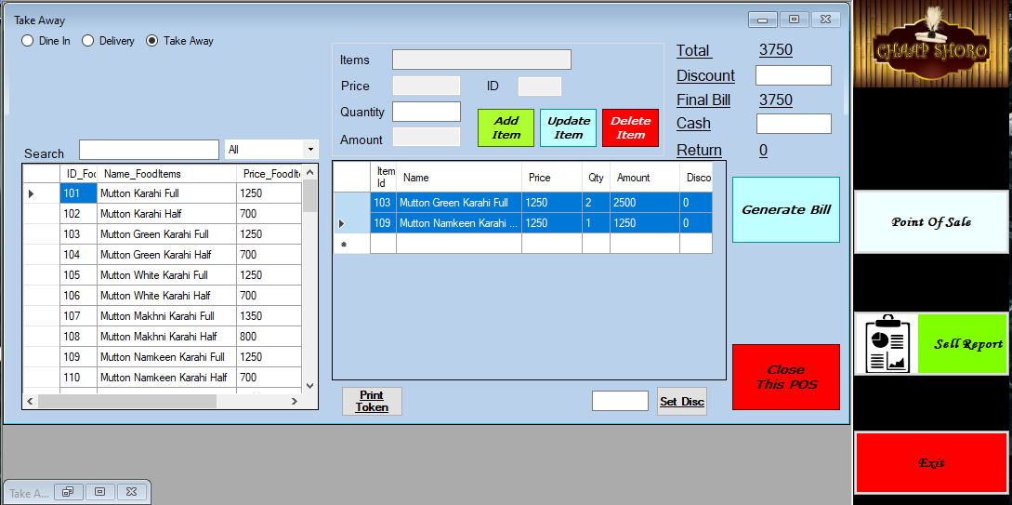

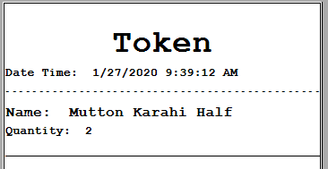

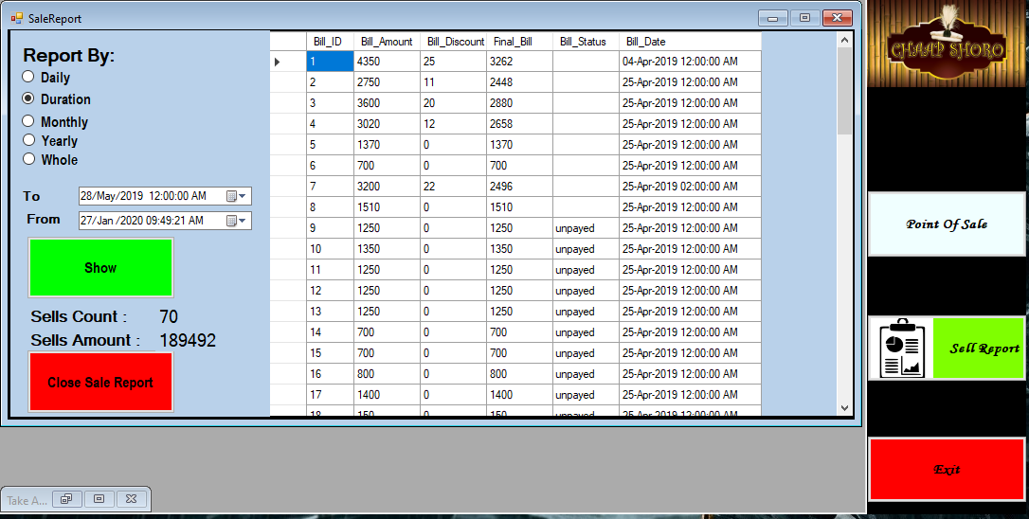

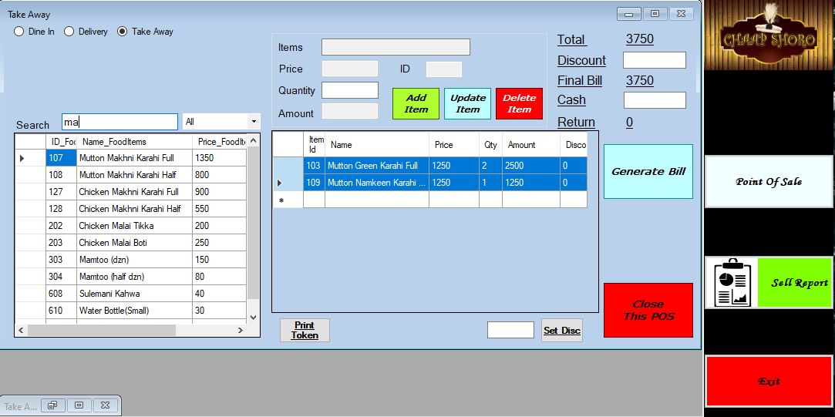

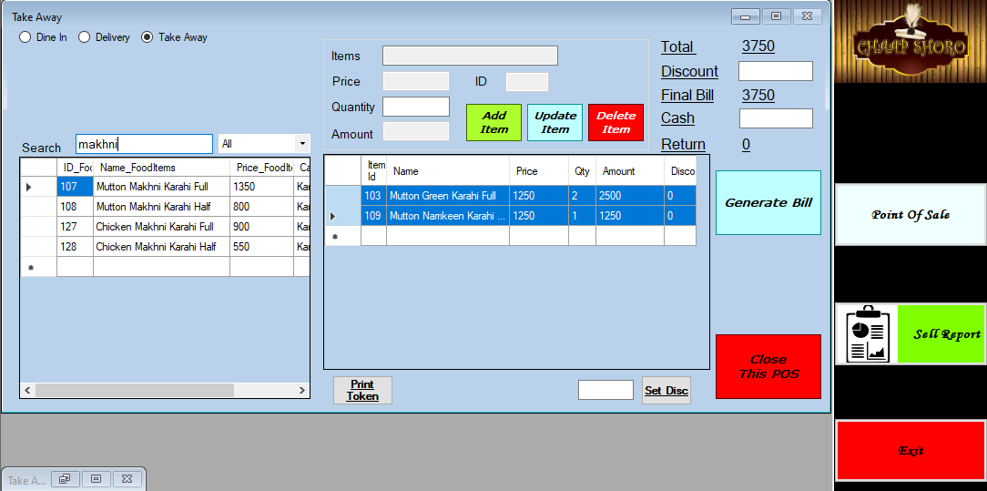

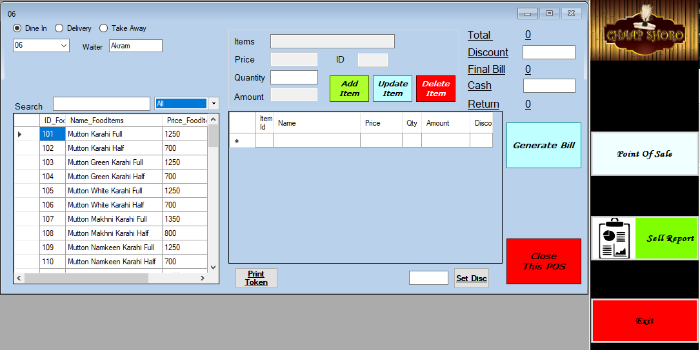

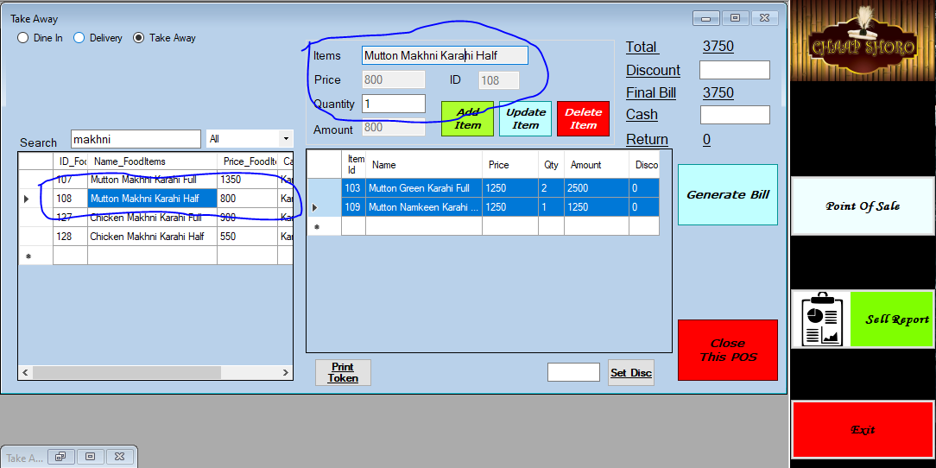

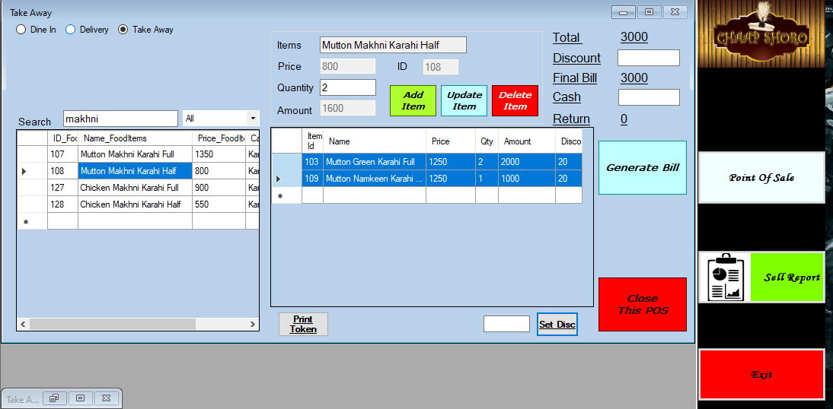

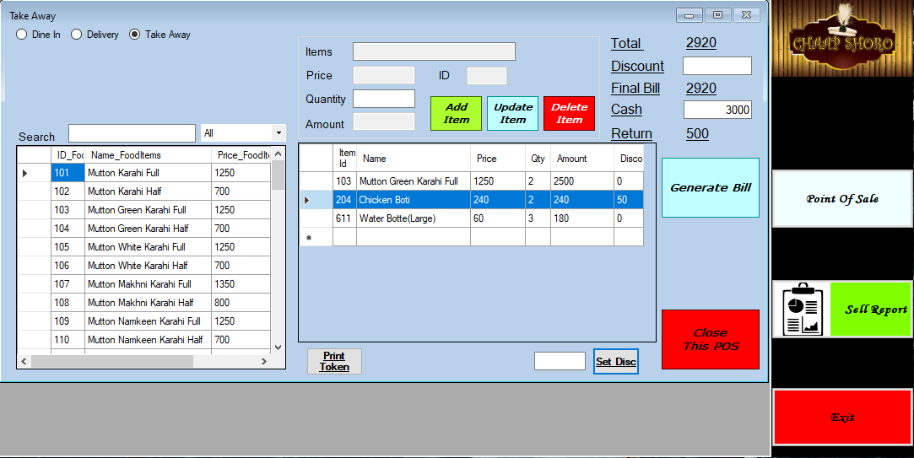

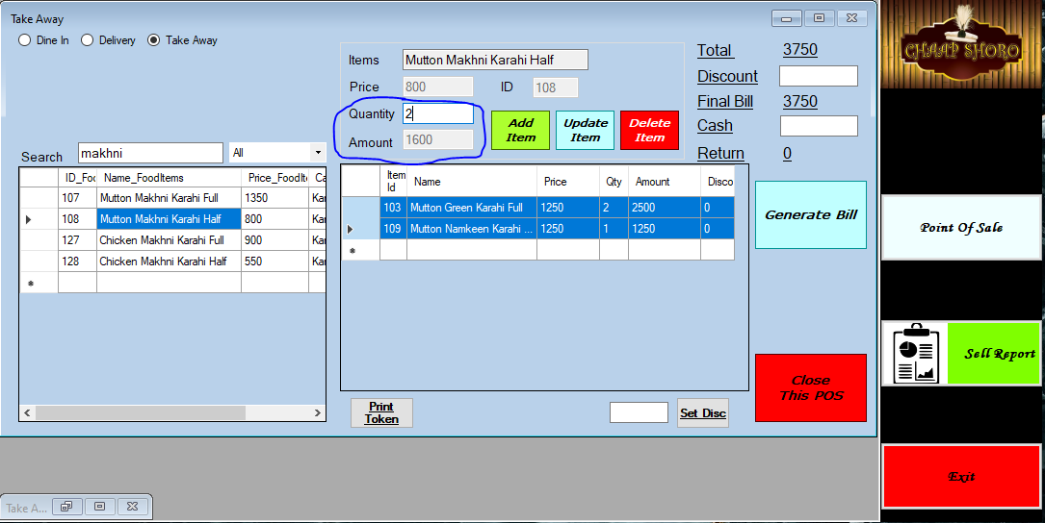

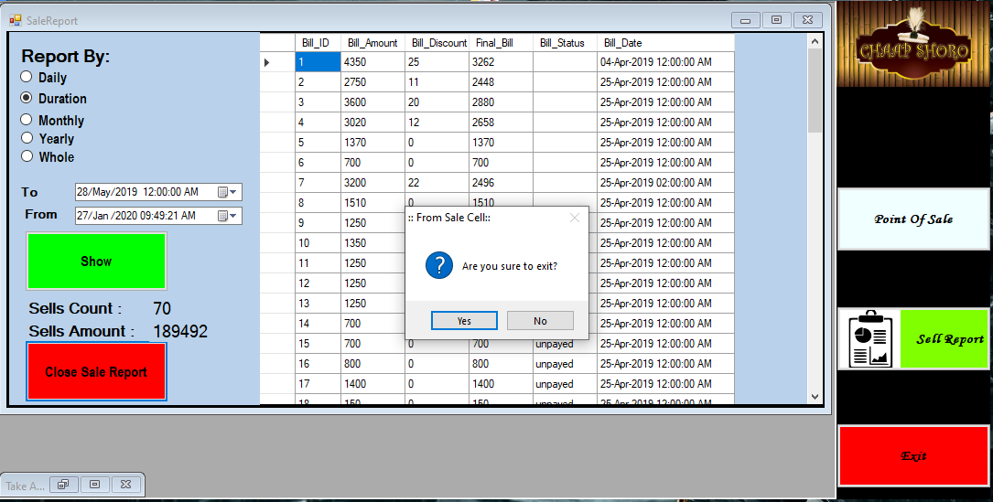

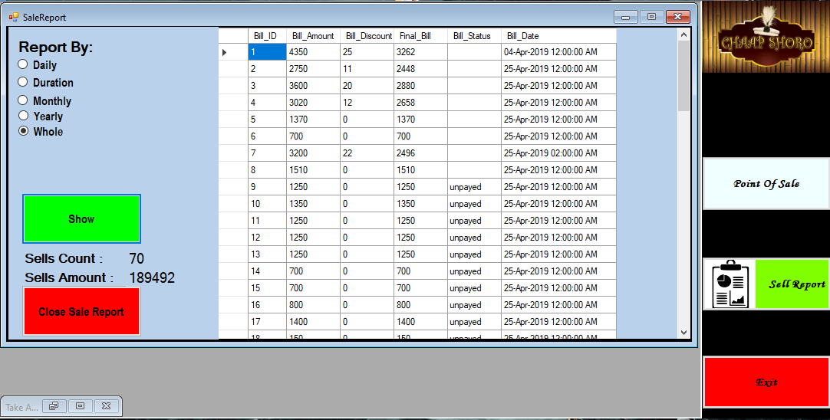

# User Manual

# Introduction to the System Document

**Purpose of this Document**

The purpose of this user manual is to familiarize the user about the reserveit system.

**Indented readers**

Readers can follow the instruction of user manual to install and use that software.

**System Responsibility**

The system is responsible is to reserve the seat in the selected restaurant and time.

# Installation Instruction

**System Overview**

The system will reserve the seat in your favorite restaurants, and you can cancel your reservation at any time.

**System Requirements**

Core 2 Duo

Windows Operating System 7 or later

.Net version 3.5 or later

2 GB of RAM, 30 Mb storage

**Installation Guide**

1. Unzip winRar file
2. Run ChapShoro Program

**Convention Used**

* Font: Times New Roman
* Size: 12
* Heading: 16

**System Navigation**

The following table will illustrate the flow of the system with description & usage.

|  |  |  |  |
| --- | --- | --- | --- |
| **Flow** | **Deliverables** | **Description** | **Usage** |
| 1 | POS | Place order and keep records of ongoing orders that are serving | Without POS you cannot ensure what order is placed and by whom |
| 2 | Sale Report | Keeping records of sales | To check sales record |

**System Reports & Maintenance**

The system itself does not generate system reports for fixing of error and the user has to manually take the screenshot and email to [cs161xxx@dsu.edu.pk](mailto:cs161xxx@dsu.edu.pk) for error fixing and maintenance and this maintenance will be entertained after two months of deployment of the System.